1. **Select a 2D image with objects to replicate in a 3D scene.** It’s recommended that you take your own photos of the 2D scene. Having multiple photos will let you look at the objects from several angles. Or you may create a sketch or find an image online. You will need to have at least four objects in your scene. At least one of these objects needs to be made of two or more basic 3D shapes. You will need to use at least four different basic 3D shapes in your work. Shape options to include in your scene are listed below:
   1. Box
   2. Cone
   3. Cylinder
   4. Plane
   5. Prism
   6. Pyramid
   7. Sphere
   8. Tapered cylinder
   9. Torus

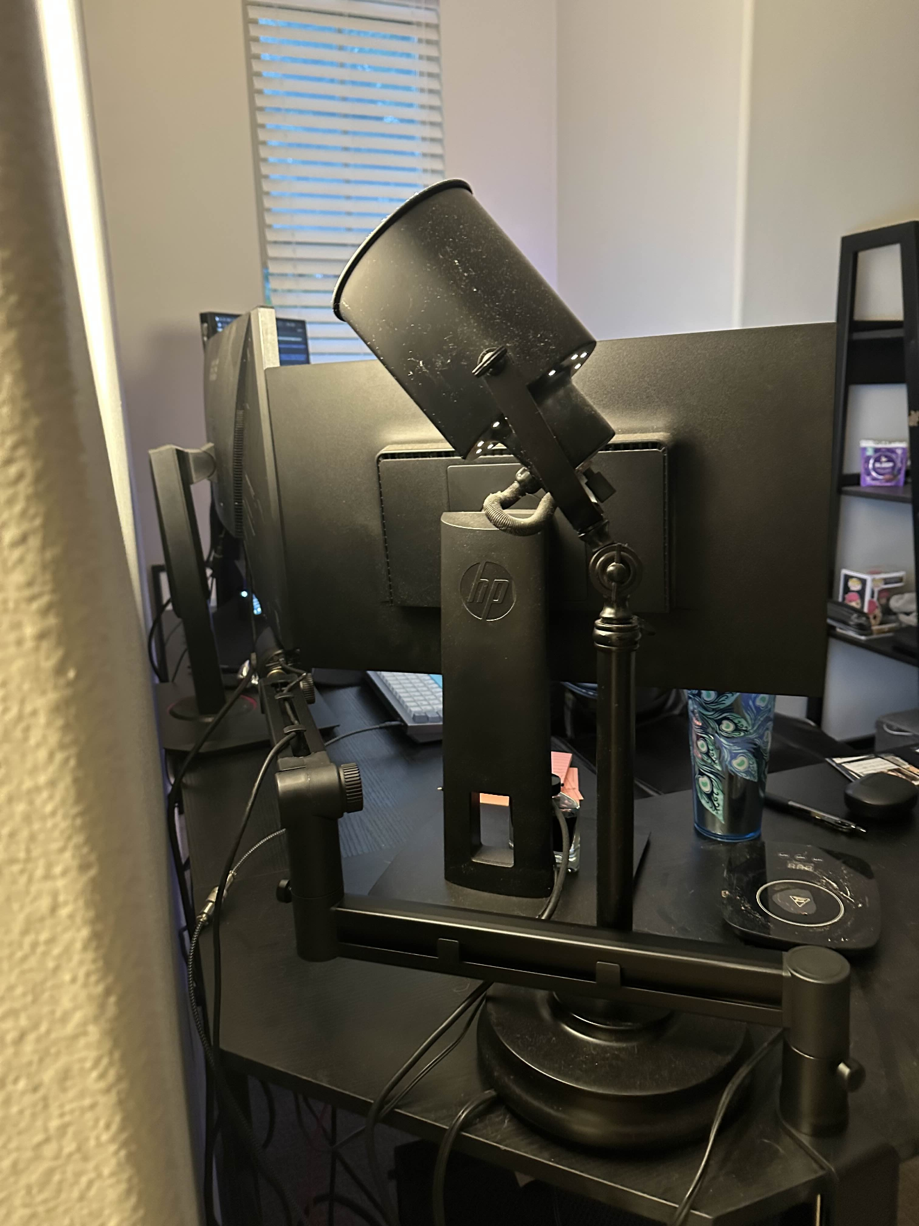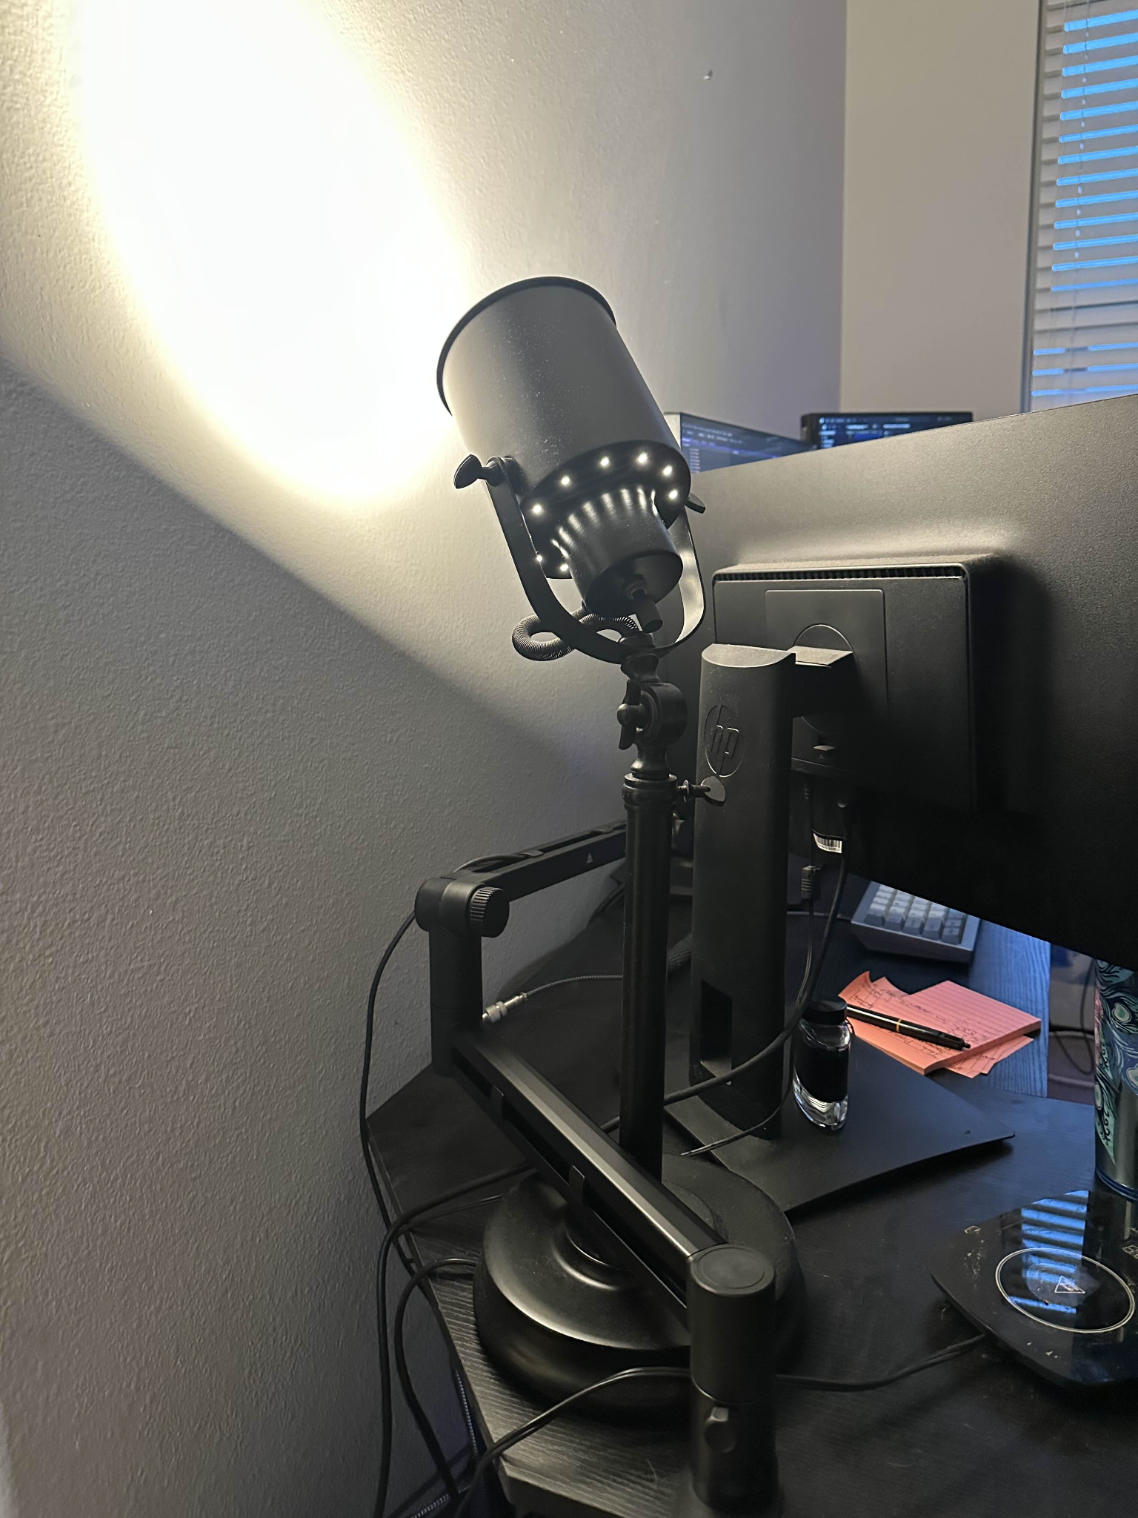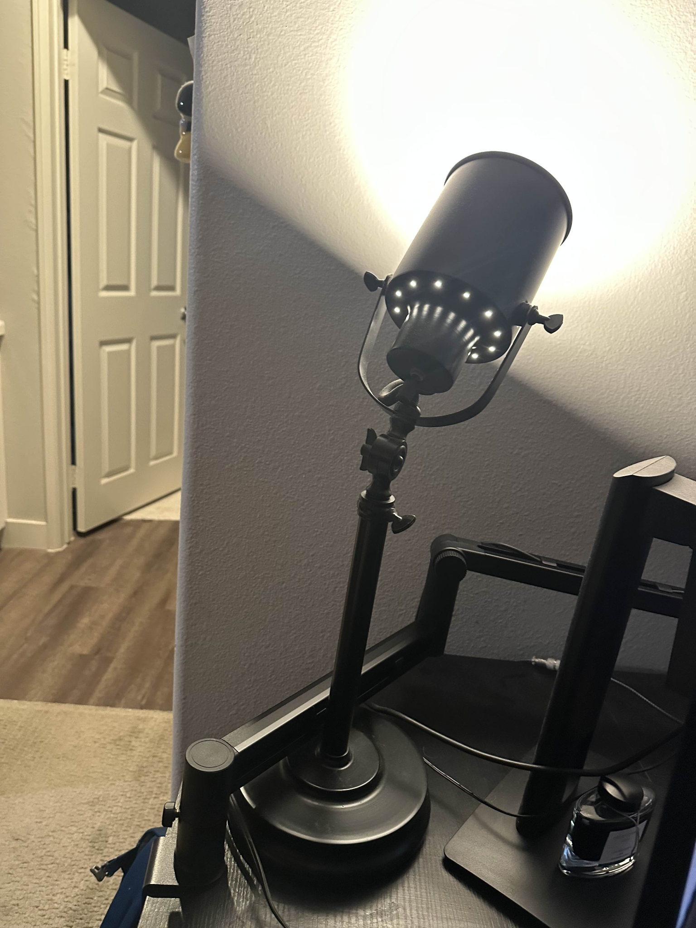

1. **Discuss which objects will be replicated in 3D**. Select which items from your scene that you will be replicating in 3D. Then explain why these items are a good choice for your work.

I will be replicating my desk lamp (dust not included). It has a bunch of interesting parts like the knobs and the U shaped bracket. I’m not sure if we are going to deal with lighting in this course, but I thought that for that work, this would be a perfect source – pun intended. Along with it I will be adding one of my fountain pen ink jars, a mug I use as a pencil holder, and this bowl I use to hold my wallet and keys.

1. **Explain which basic 3D shapes will be used to replicate the 2D objects**. Break down each of the objects you chose into their component shapes. Be sure to include a plane in your scene. The plane will be used to ground the rest of the objects. Explain why your choices make sense and how you will carry out the overall scope of the work. The goal is to ensure the selections you make are exciting to explore but also achievable.

The lamp has a bunch of primitives in it – mostly cylinders though. I would use cylinders for the base, pole, lamp shade, and the power cable cover that snakes around. I would use squished spheres for the knobs and either a plane or a box bent into the U shape to be determined once I get in there and play around with it and see what works best. The bulb would be made out of a sphere with a cone on it. It could certainly be more complicated with the cone having a logarithmic tapering into a cylinder with a threading on it, but I will decide based on how much time it takes me to make the rest of it and still create something that most closely resembles a lightbulb with the time I have left. Regarding the ink jar, I will be using two cylinders, one squished to make that flat face and one on top making the lid. The mug will be made of a torus and a cylinder, and the bowl will be made out of a tapered cylinder with another internal tapered cylinder slightly smaller for negative space making it generally bowl shaped.